CUSTOMSTRACK AI COMPLETE SOFTWARE ARCHITECTURE
This document presents the complete technical architecture for CustomsTrack AI, a mobile-first destination visualization and inspection support subsystem integrated with CAMCIS, per the approved Software Requirements Specification. It reflects the confirmed dual-interface design (a React Native mobile app as the main operational tool, and a lightweight React.js web dashboard for administration), and the bidirectional CAMCIS relationship: declarations are retrieved from CAMCIS (simulated during development), and completed inspection reports are synchronized back to CAMCIS once official integration is authorized. No implementation code is included; this is a design-level reference for Chapter Four.
Business rules reflected throughout this design: CAMCIS remains the official customs platform; the application never modifies CAMCIS declarations; declaration data is simulated during development; every inspection belongs to exactly one declaration; inspection reports are stored locally before and regardless of synchronization; failed synchronizations never delete reports; inspection history cannot be deleted; only Administrators manage users; and AI only assists officers — final decisions remain human.
1. Folder Structure
The system is organised as three codebases sharing one API contract: the backend, the mobile app (the main operational tool), and the web dashboard (the administrative companion).
1.1 Backend (Node.js / Express)
backend/
├── src/
│ ├── config/ (db connection, environment, constants)
│ ├── models/ (Mongoose schemas — Section 6)
│ ├── routes/
│ ├── controllers/
│ ├── services/
│ │ ├── authService.js
│ │ ├── declarationService.js (retrieves from CAMCIS / simulated data)
│ │ ├── mapService.js
│ │ ├── inspectionService.js
│ │ ├── synchronizationService.js (queue, push, retry — Section 15)
│ │ ├── aiService.js (future phase — OCR + GPT)
│ │ └── dashboardService.js (computes metrics dynamically)
│ ├── middleware/ (authMiddleware, rbacMiddleware, errorHandler, uploadMiddleware)
│ ├── jobs/
│ │ └── syncWorker.js (background job: processes SynchronizationQueue)
│ ├── utils/ (logger, validators)
│ ├── data/
│ │ └── simulatedDeclarations.json (realistic sample data standing in for CAMCIS)
│ └── app.js
├── server.js
├── package.json
└── .env
1.2 Mobile App (React Native / Expo — main operational tool)
mobile-app/
├── src/
│ ├── screens/
│ │ ├── LoginScreen.js
│ │ ├── SearchScreen.js (declaration number / truck plate)
│ │ ├── DeclarationDetailScreen.js
│ │ ├── MapScreen.js
│ │ ├── InspectionScreen.js (photos, comments, save/submit)
│ │ └── DashboardSummaryScreen.js
│ ├── components/
│ ├── navigation/ (AppNavigator.js — role-based routing)
│ ├── context/ (AuthContext, OfflineQueueContext)
│ ├── services/ (apiClient, authService, mapService)
│ └── assets/
├── android/
├── ios/
└── package.json
1.3 Web Dashboard (React.js — administrative companion)
web-dashboard/
├── src/
│ ├── components/ (common, dashboard, users, sync-monitor)
│ ├── pages/
│ │ ├── LoginPage.jsx
│ │ ├── DashboardPage.jsx
│ │ ├── UsersPage.jsx (Administrator)
│ │ ├── ConfigurationPage.jsx (Administrator)
│ │ ├── SynchronizationPage.jsx (Administrator, Supervisor)
│ │ ├── InspectionHistoryPage.jsx (Supervisor)
│ │ └── StatisticsPage.jsx (Supervisor)
│ ├── services/ (apiClient, authService)
│ ├── context/ (AuthContext)
│ └── assets/
├── public/
└── package.json
Note: per the SRS, the web dashboard is intentionally lightweight and does not attempt to replace CAMCIS's own dashboards; its role is application administration, synchronization monitoring, and operational visibility, not customs declaration management.
2. Clean Architecture
The backend follows Clean Architecture principles: dependencies point inward only, so the core business rules (Entities and Use Cases) have no knowledge of the frameworks, database, or delivery mechanism surrounding them. This keeps the system able to change its outer layers, for example, swapping simulated CAMCIS data for a real integration, without touching the core logic.
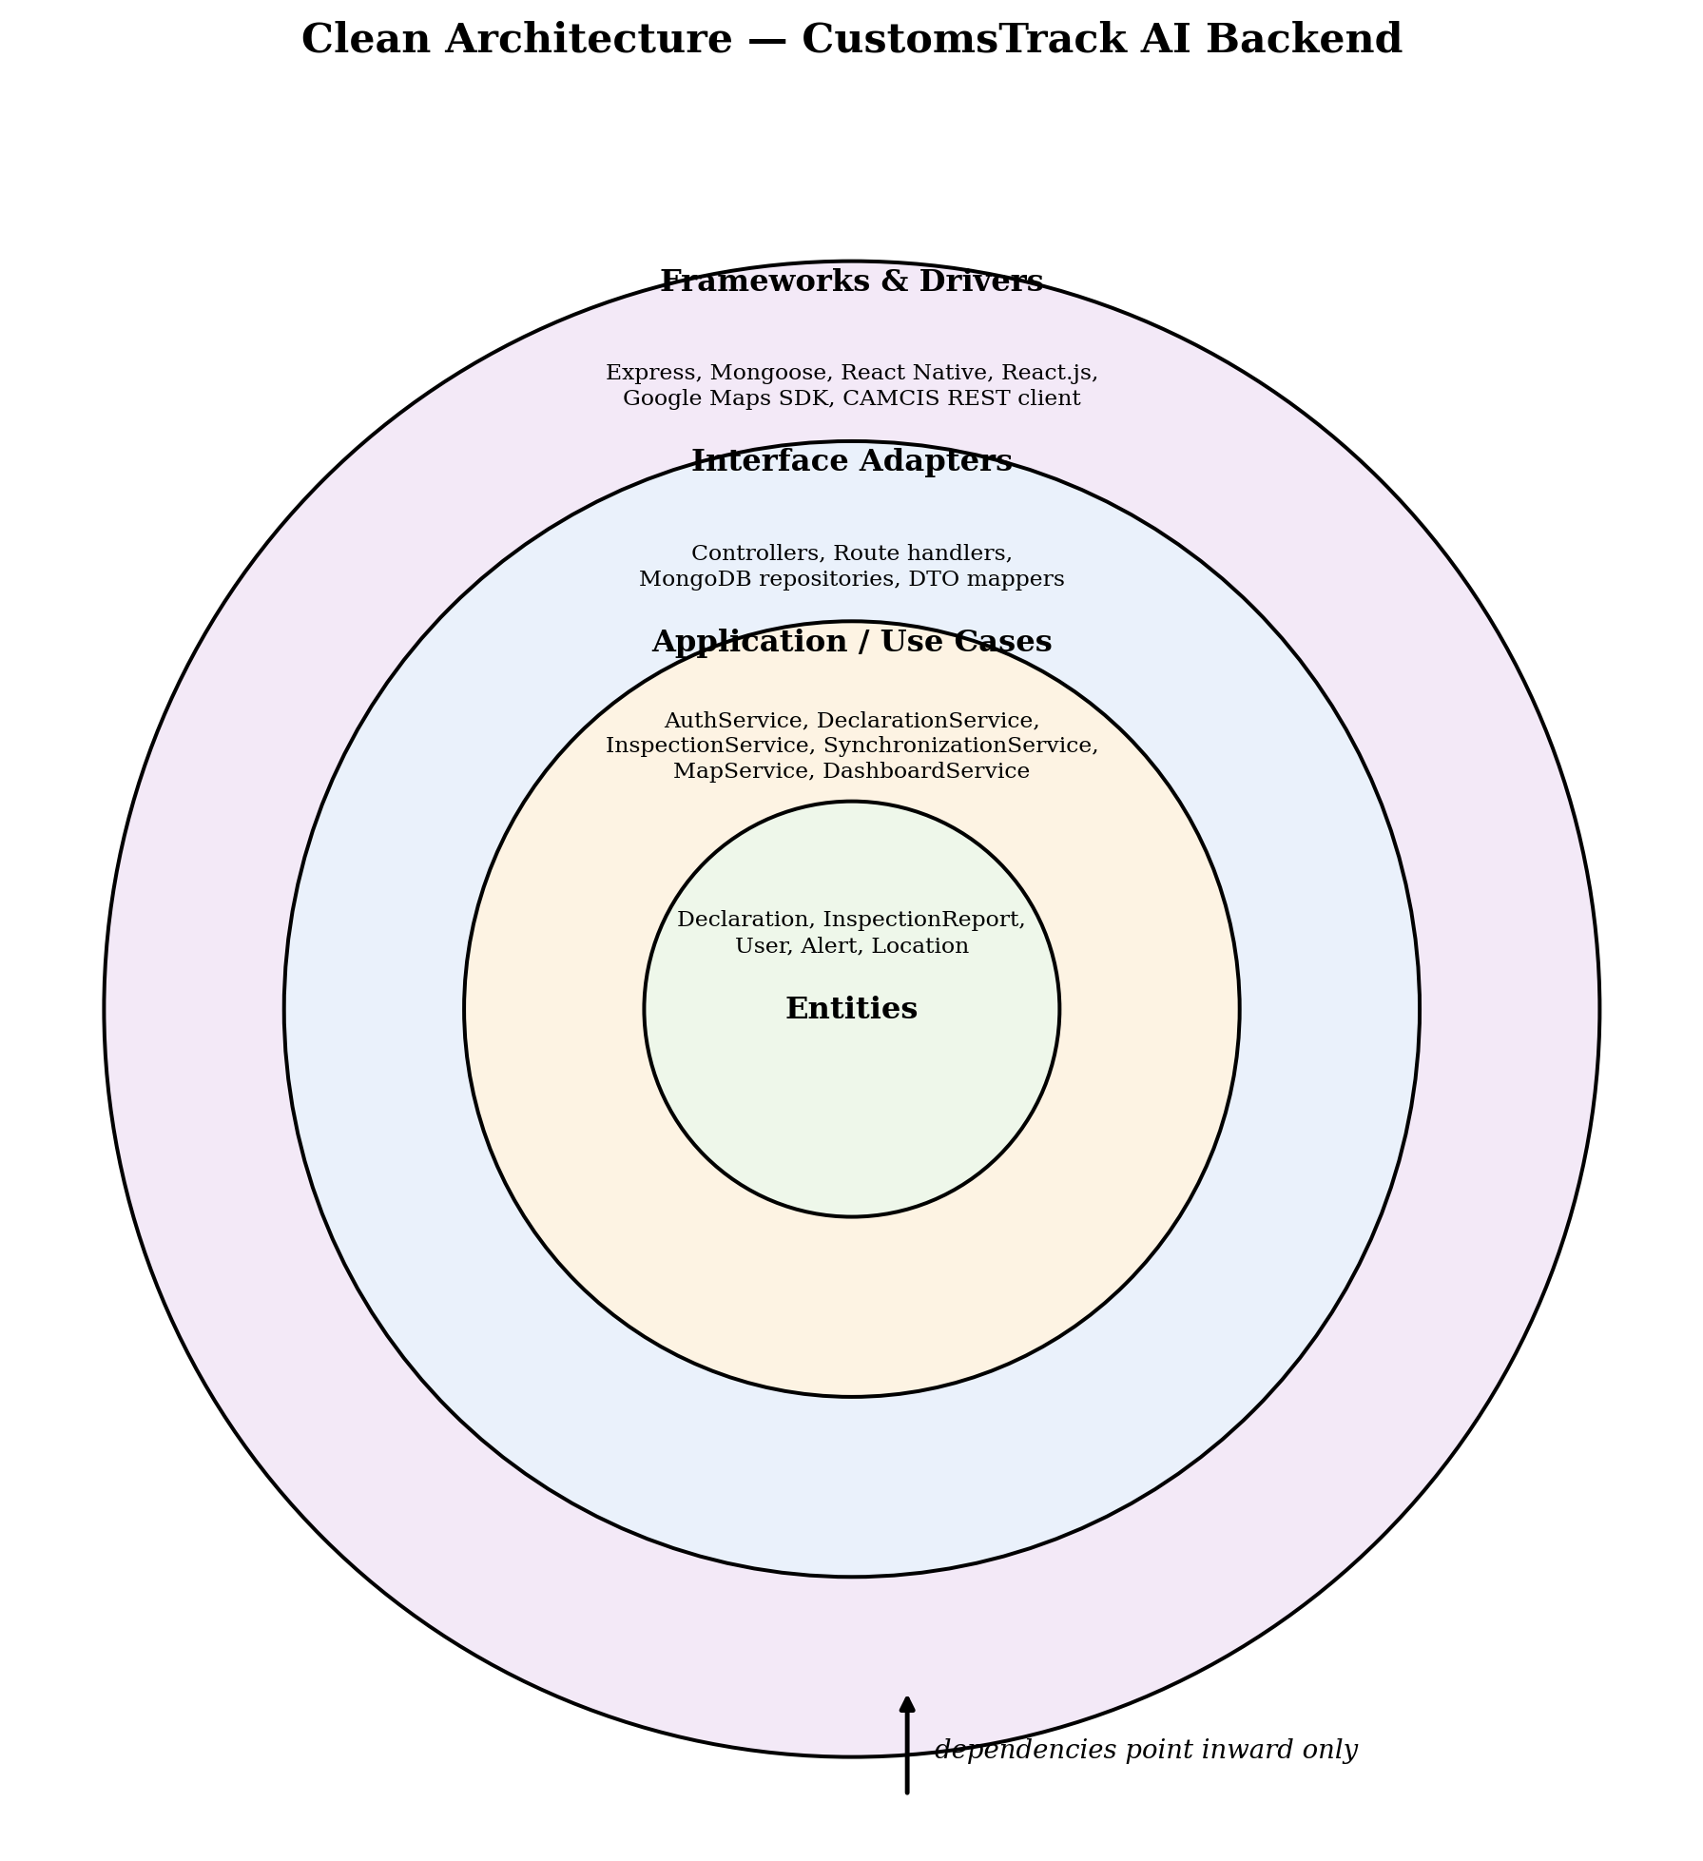
Figure 1: Clean Architecture applied to the CustomsTrack AI backend.
3. Layered Architecture
At a system-wide level, CustomsTrack AI is organised into five layers: the presentation layer (both client applications), the API layer, the business logic (service) layer, the data layer, and external services. The Synchronization Service is highlighted separately because, unlike the other services, it communicates outbound to CAMCIS rather than only inbound.
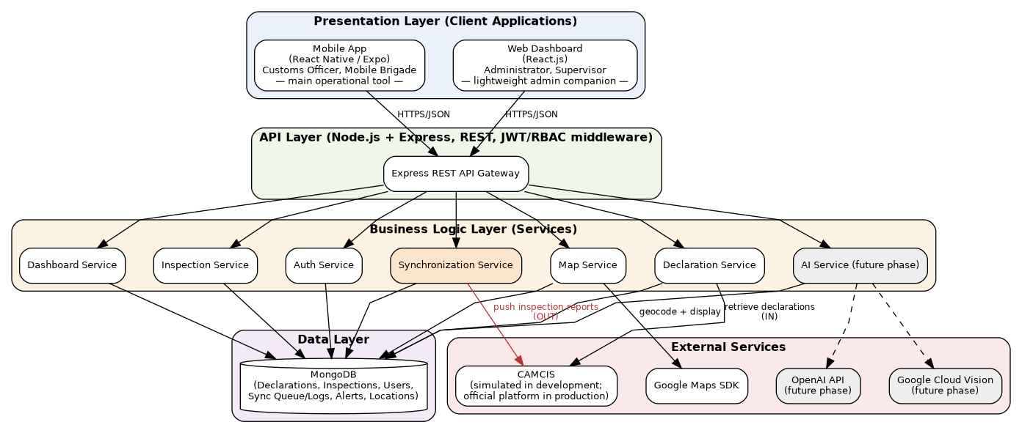
Figure 2: Layered architecture showing both client interfaces and the bidirectional CAMCIS relationship.
4. Mobile Architecture
The mobile app is structured into a UI (screens) layer, a role-based navigation layer, a state/context layer, and a service layer. An offline queue is included because Mobile Brigade officers frequently work in areas with unreliable connectivity: inspections created offline are held locally and pushed to the backend once connectivity resumes, independent of the backend's own CAMCIS synchronization queue.
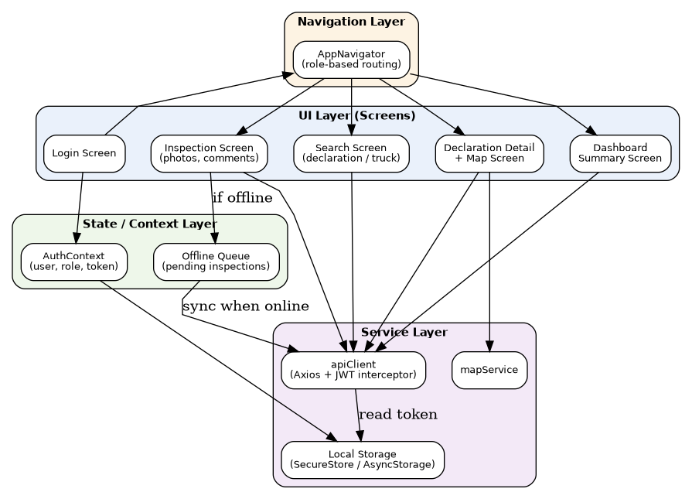
Figure 3: Mobile application internal architecture.
5. Backend Architecture
The backend follows a conventional Express request pipeline: routes delegate to authentication and RBAC middleware, then to thin controllers, which delegate all business logic to services, which alone are permitted to touch the Mongoose models.
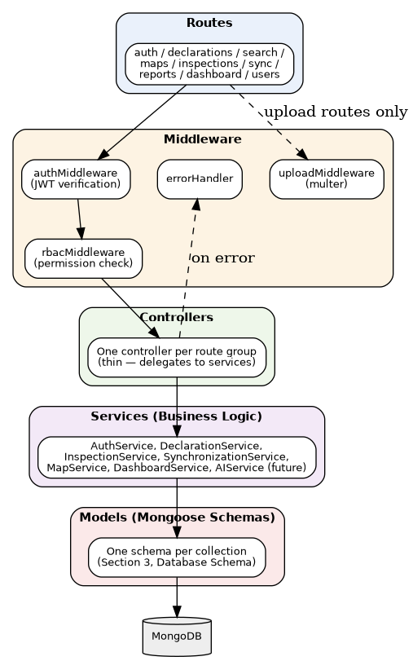
Figure 4: Backend internal architecture (request pipeline).
6. Database Schema
Per SRS Section 8, eighteen entities are defined. Statistics are explicitly computed dynamically rather than stored, per Section 12 of the project specification. AIExtractions is not part of the approved entity list but is noted below as a recommended future addition once the AI Module (currently a future-phase enhancement per Section 13) is implemented.
6.1 Users, Roles, Permissions
Field | Type | Description
Users._id, name, email, passwordHash, roleId, status, createdAt | — | Application user accounts
Roles._id, name, description | — | Administrator / Customs Officer / Mobile Brigade / Supervisor
Permissions._id, name, description, roleIds | — | Fine-grained access control per role
6.2 Importers, Declarations, Goods
Field | Type | Description
Importers._id, name, niu, address, contact | — | Declaring importer / company
Declarations._id, declarationNumber, camcisReference, importerId, transportCompanyId, driverId, vehicleId, destinationLocationId, status, source | — | source distinguishes 'simulated' (development) from 'camcis' (production)
Goods._id, declarationId, description, weight, packages, hsCode | — | Goods line items per declaration
6.3 TransportCompanies, Drivers, Vehicles
Field | Type | Description
TransportCompanies._id, name, contact | — | Carrier company
Drivers._id, transportCompanyId, name, licenseNumber, phone | — | Driver particulars
Vehicles._id, transportCompanyId, plateNumber, type | — | Vehicle particulars
6.4 Documents
Field | Type | Description
_id | ObjectId | Primary key
declarationId | ObjectId (ref: Declarations) | Parent declaration
type | String | billOfLading / invoice / packingList / transportDoc
fileUrl | String | Cloudinary URL (future) or local storage path (development)
uploadedBy | ObjectId (ref: Users) | Uploading officer
aiStatus | String | not_processed — reserved for future AI Module
uploadedAt | Date | Upload timestamp
6.5 InspectionReports, InspectionPhotos
Field | Type | Description
_id | ObjectId | Primary key
declarationId | ObjectId (ref: Declarations) | Exactly one parent declaration (Business Rule)
officerId | ObjectId (ref: Users) | Inspecting officer
locationId | ObjectId (ref: Locations) | Inspection site
result | String | Inspection outcome
comments | String | Officer remarks
status | String | draft / submitted / queued / synced / failed
date | Date | Inspection date
InspectionPhotos._id, reportId, fileUrl, uploadedAt | — | Photos attached to a report
6.6 Alerts, Locations, AuditLogs
Field | Type | Description
Alerts._id, declarationId, type, message, status, createdAt | — | Warnings (from AI Module, future phase, or manual flags)
Locations._id, name, latitude, longitude, geocodedFrom | — | Geocoded destination or inspection-site coordinates
AuditLogs._id, userId, action, targetEntity, targetId, timestamp | — | Audit trail of sensitive actions
6.7 SynchronizationQueue, SynchronizationLogs, SyncStatus
Field | Type | Description
_id | ObjectId | Primary key
inspectionReportId | ObjectId (ref: InspectionReports) | Report awaiting synchronization
status | String | pending / processing / completed / failed
attempts | Number | Retry count
createdAt / lastAttemptAt | Date | Queue timestamps
Field | Type | Description
SynchronizationLogs._id, queueId, attemptNumber, status, responseMessage, timestamp | — | Full audit trail of every sync attempt, success or failure
SyncStatus._id, referenceType, referenceId, status, lastUpdated | — | Fast-lookup current sync state, without querying full log history
7. Entity-Relationship (ER) Diagram
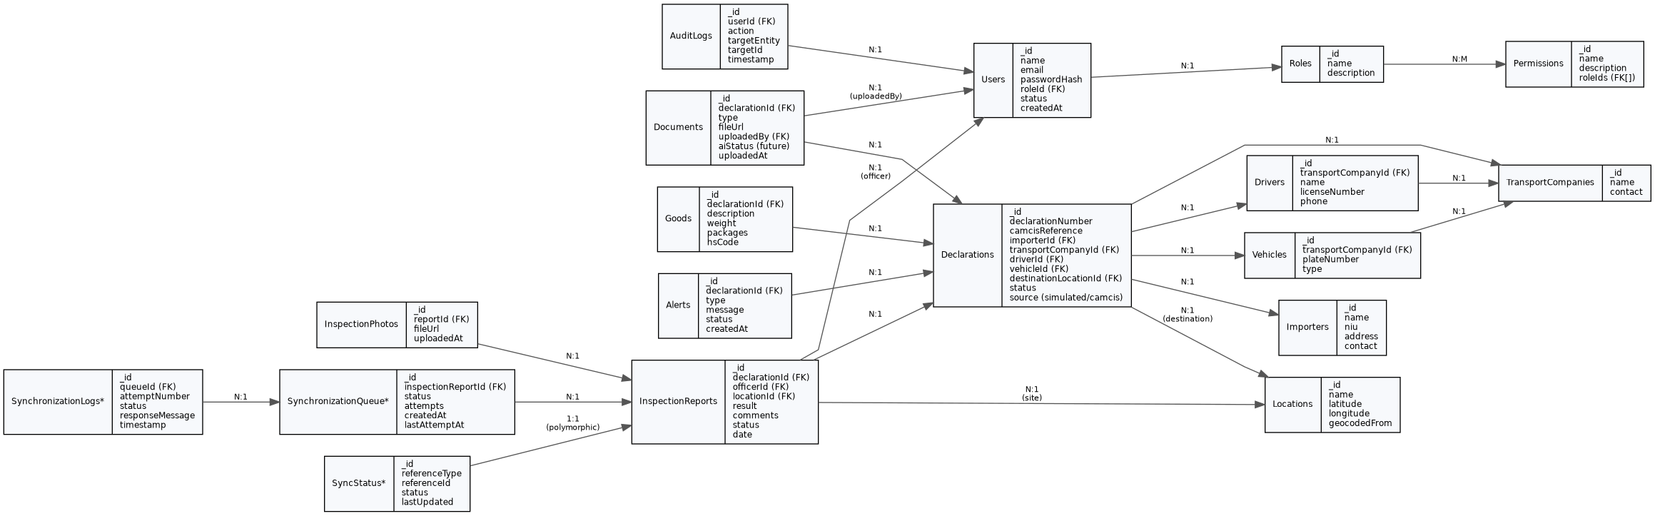
Figure 5: Entity-relationship diagram (entities marked * are recommended additions beyond the approved SRS entity list).
8. Class Diagram
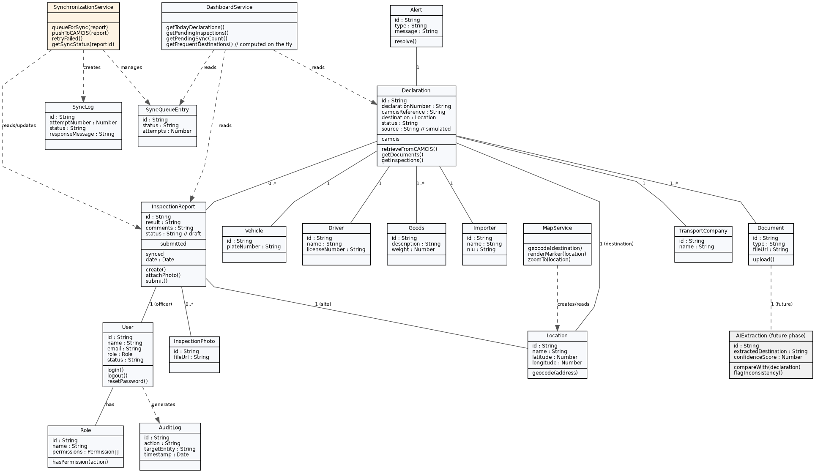
Figure 6: Conceptual class diagram, including the Synchronization Service and future-phase AI classes (shaded).
9. Sequence Diagrams
Four sequence diagrams are provided, covering the system's most significant cross-component interactions: authentication (shared by both client applications), search and map display, inspection creation and submission, and report synchronization with retry.
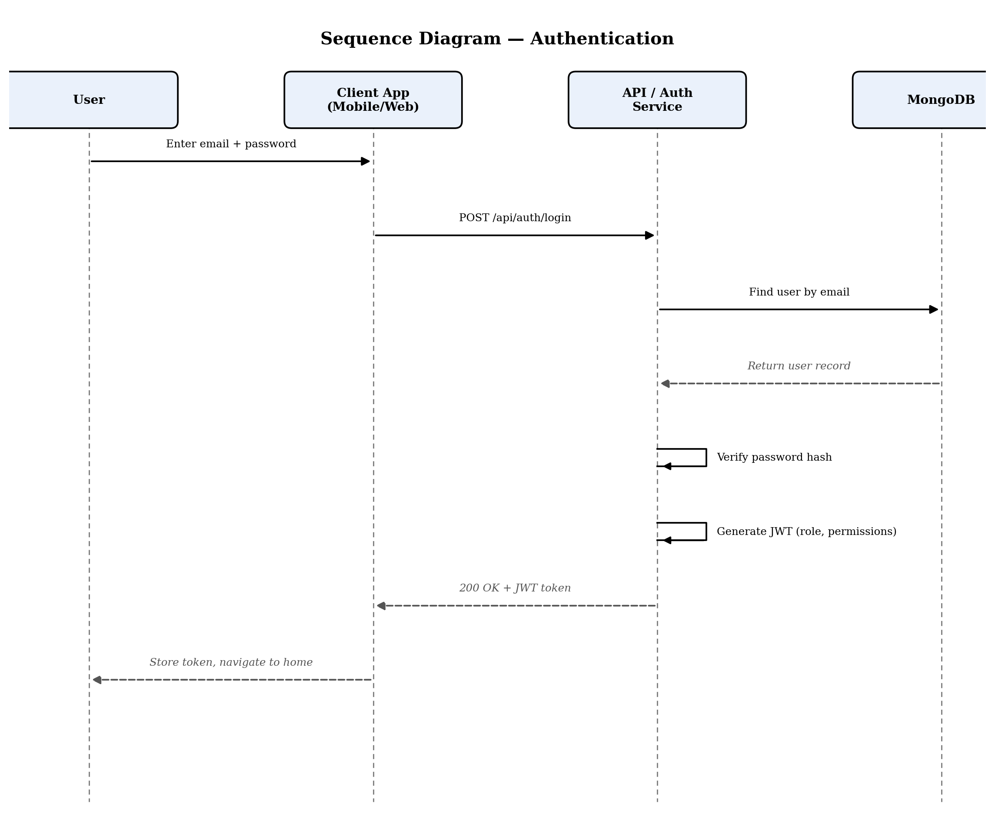
Figure 7: Sequence diagram — authentication.
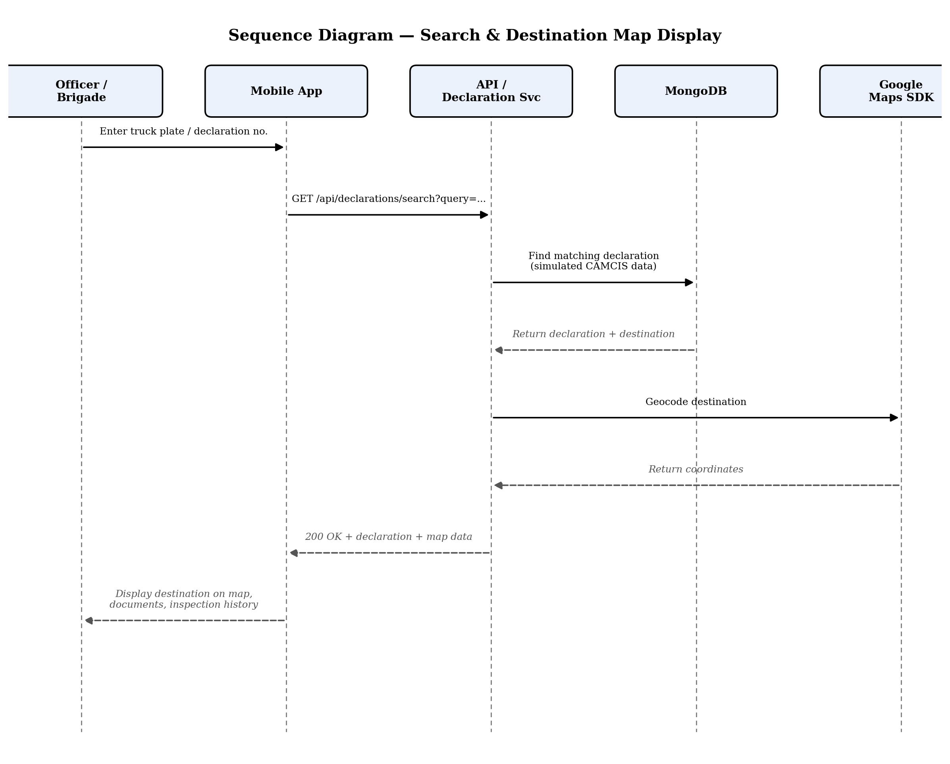
Figure 8: Sequence diagram — search and destination map display.
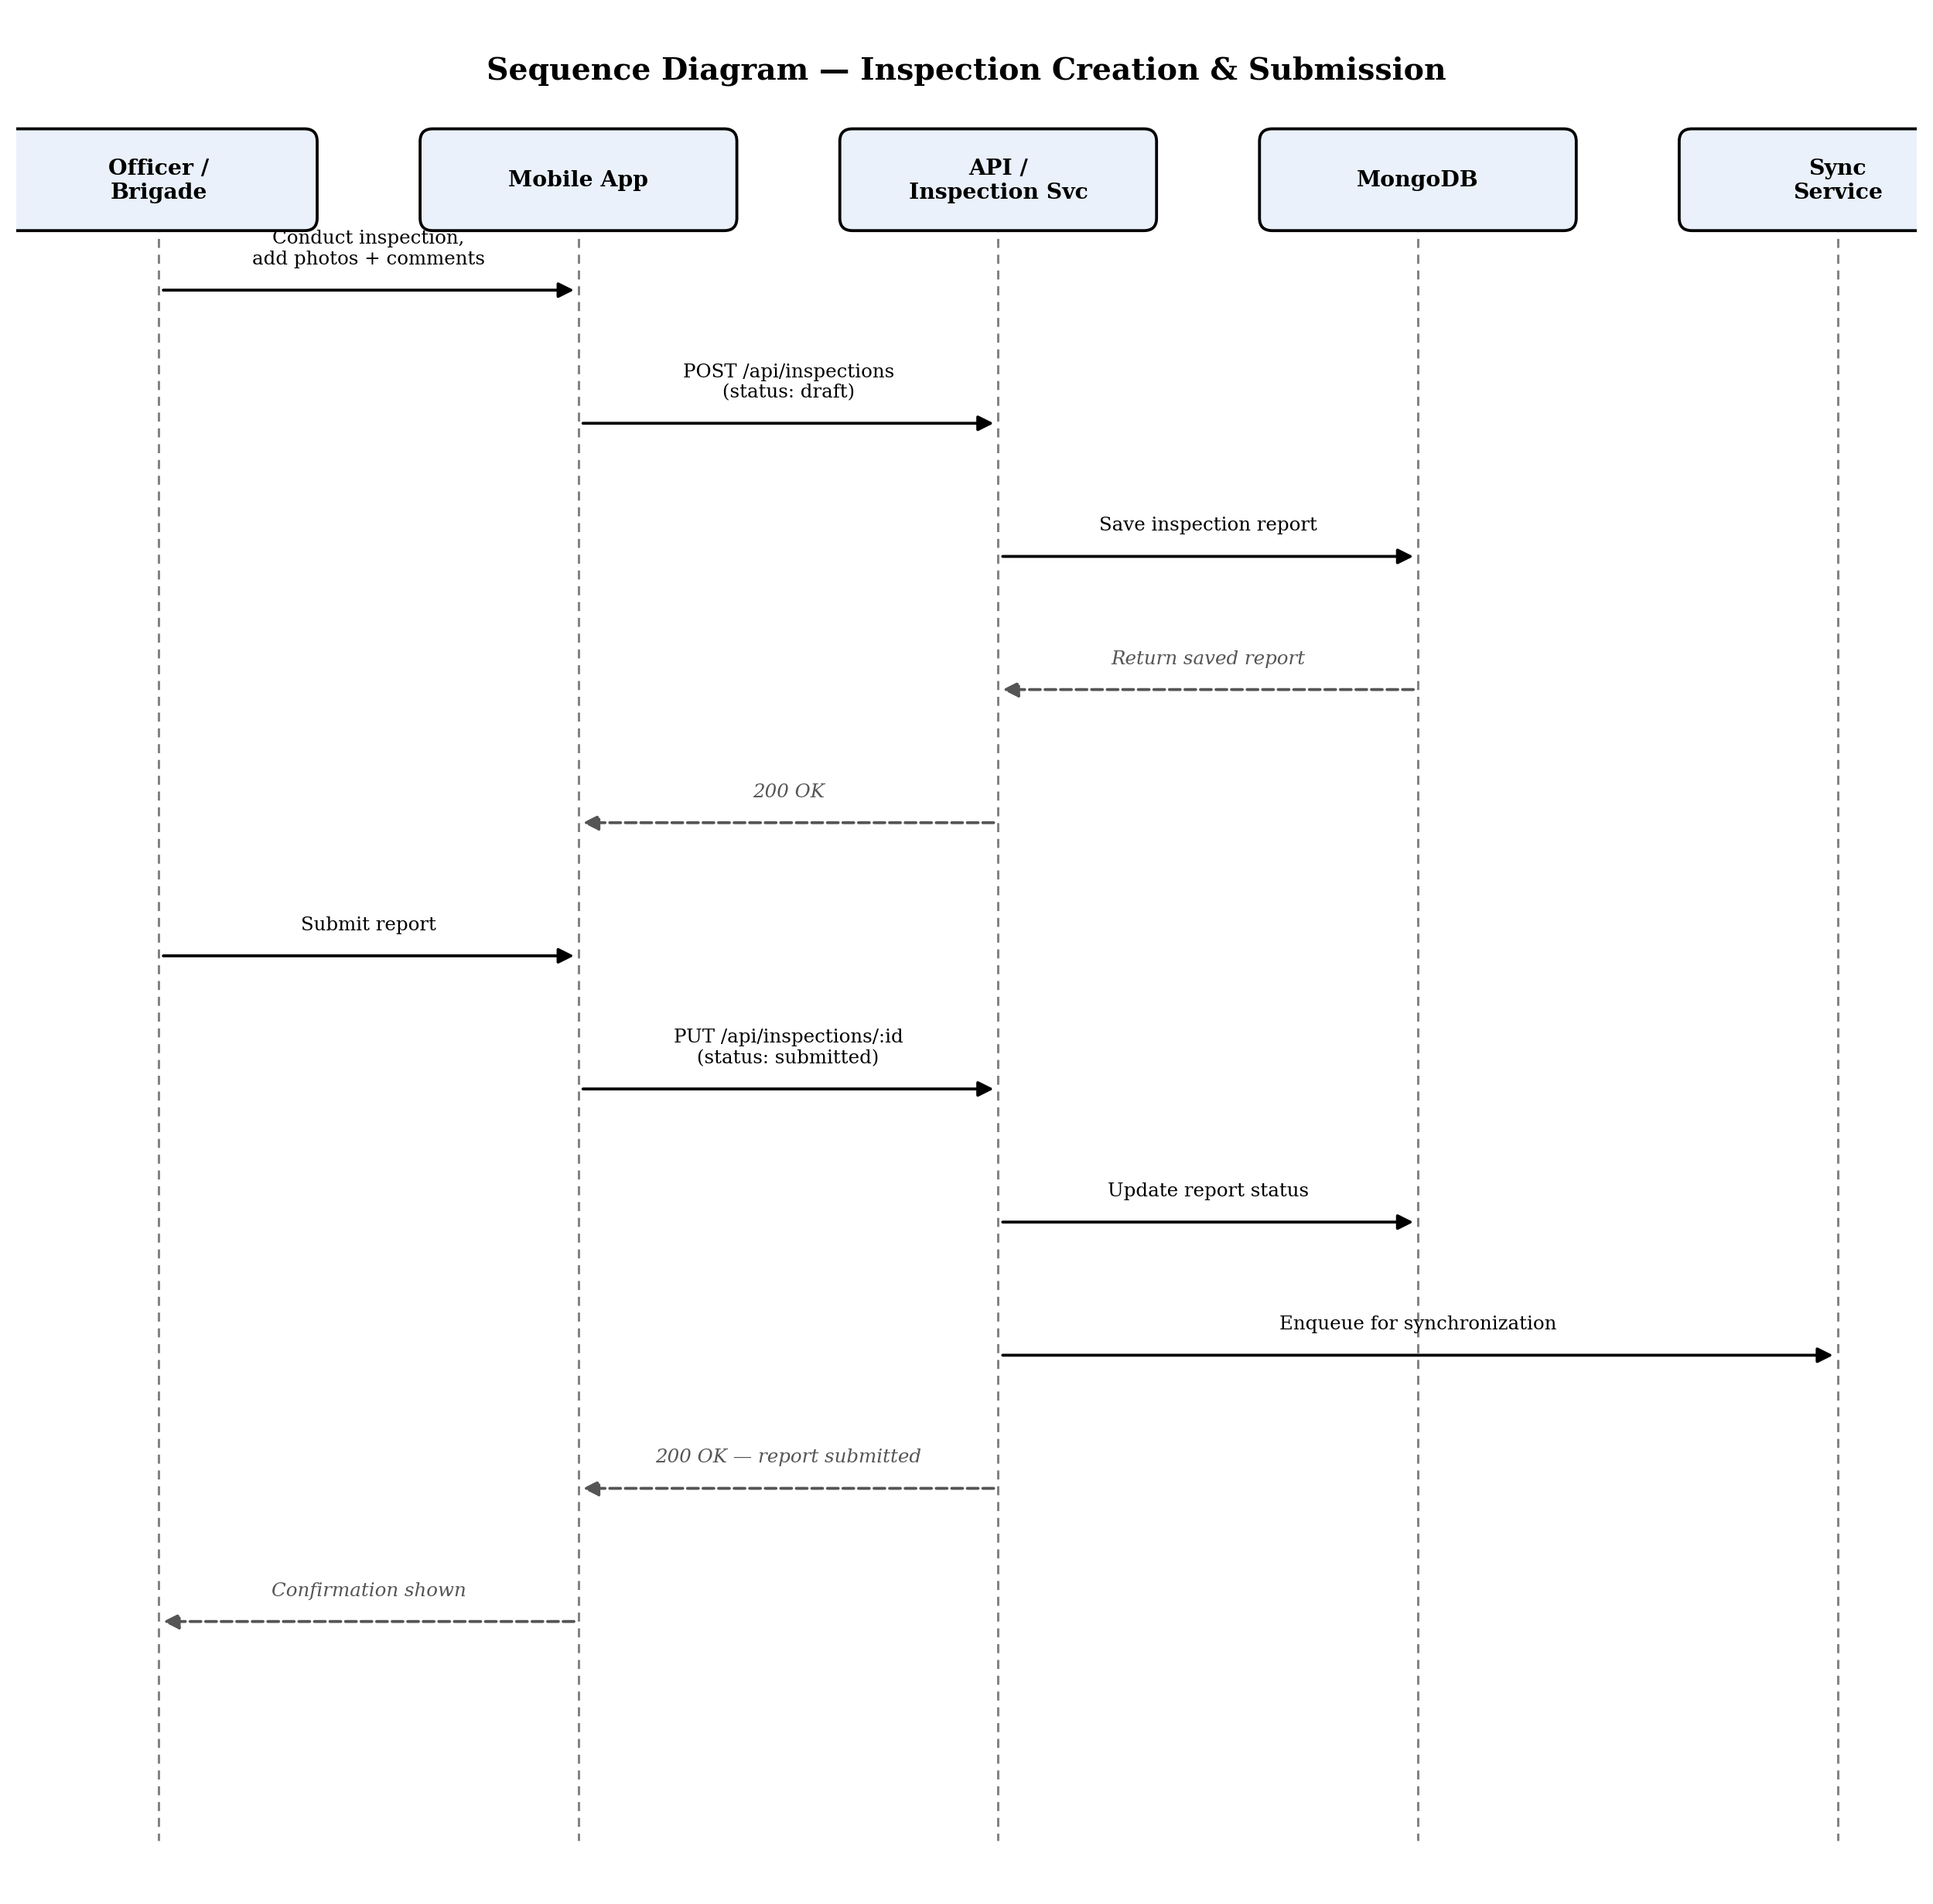
Figure 9: Sequence diagram — inspection creation and submission.
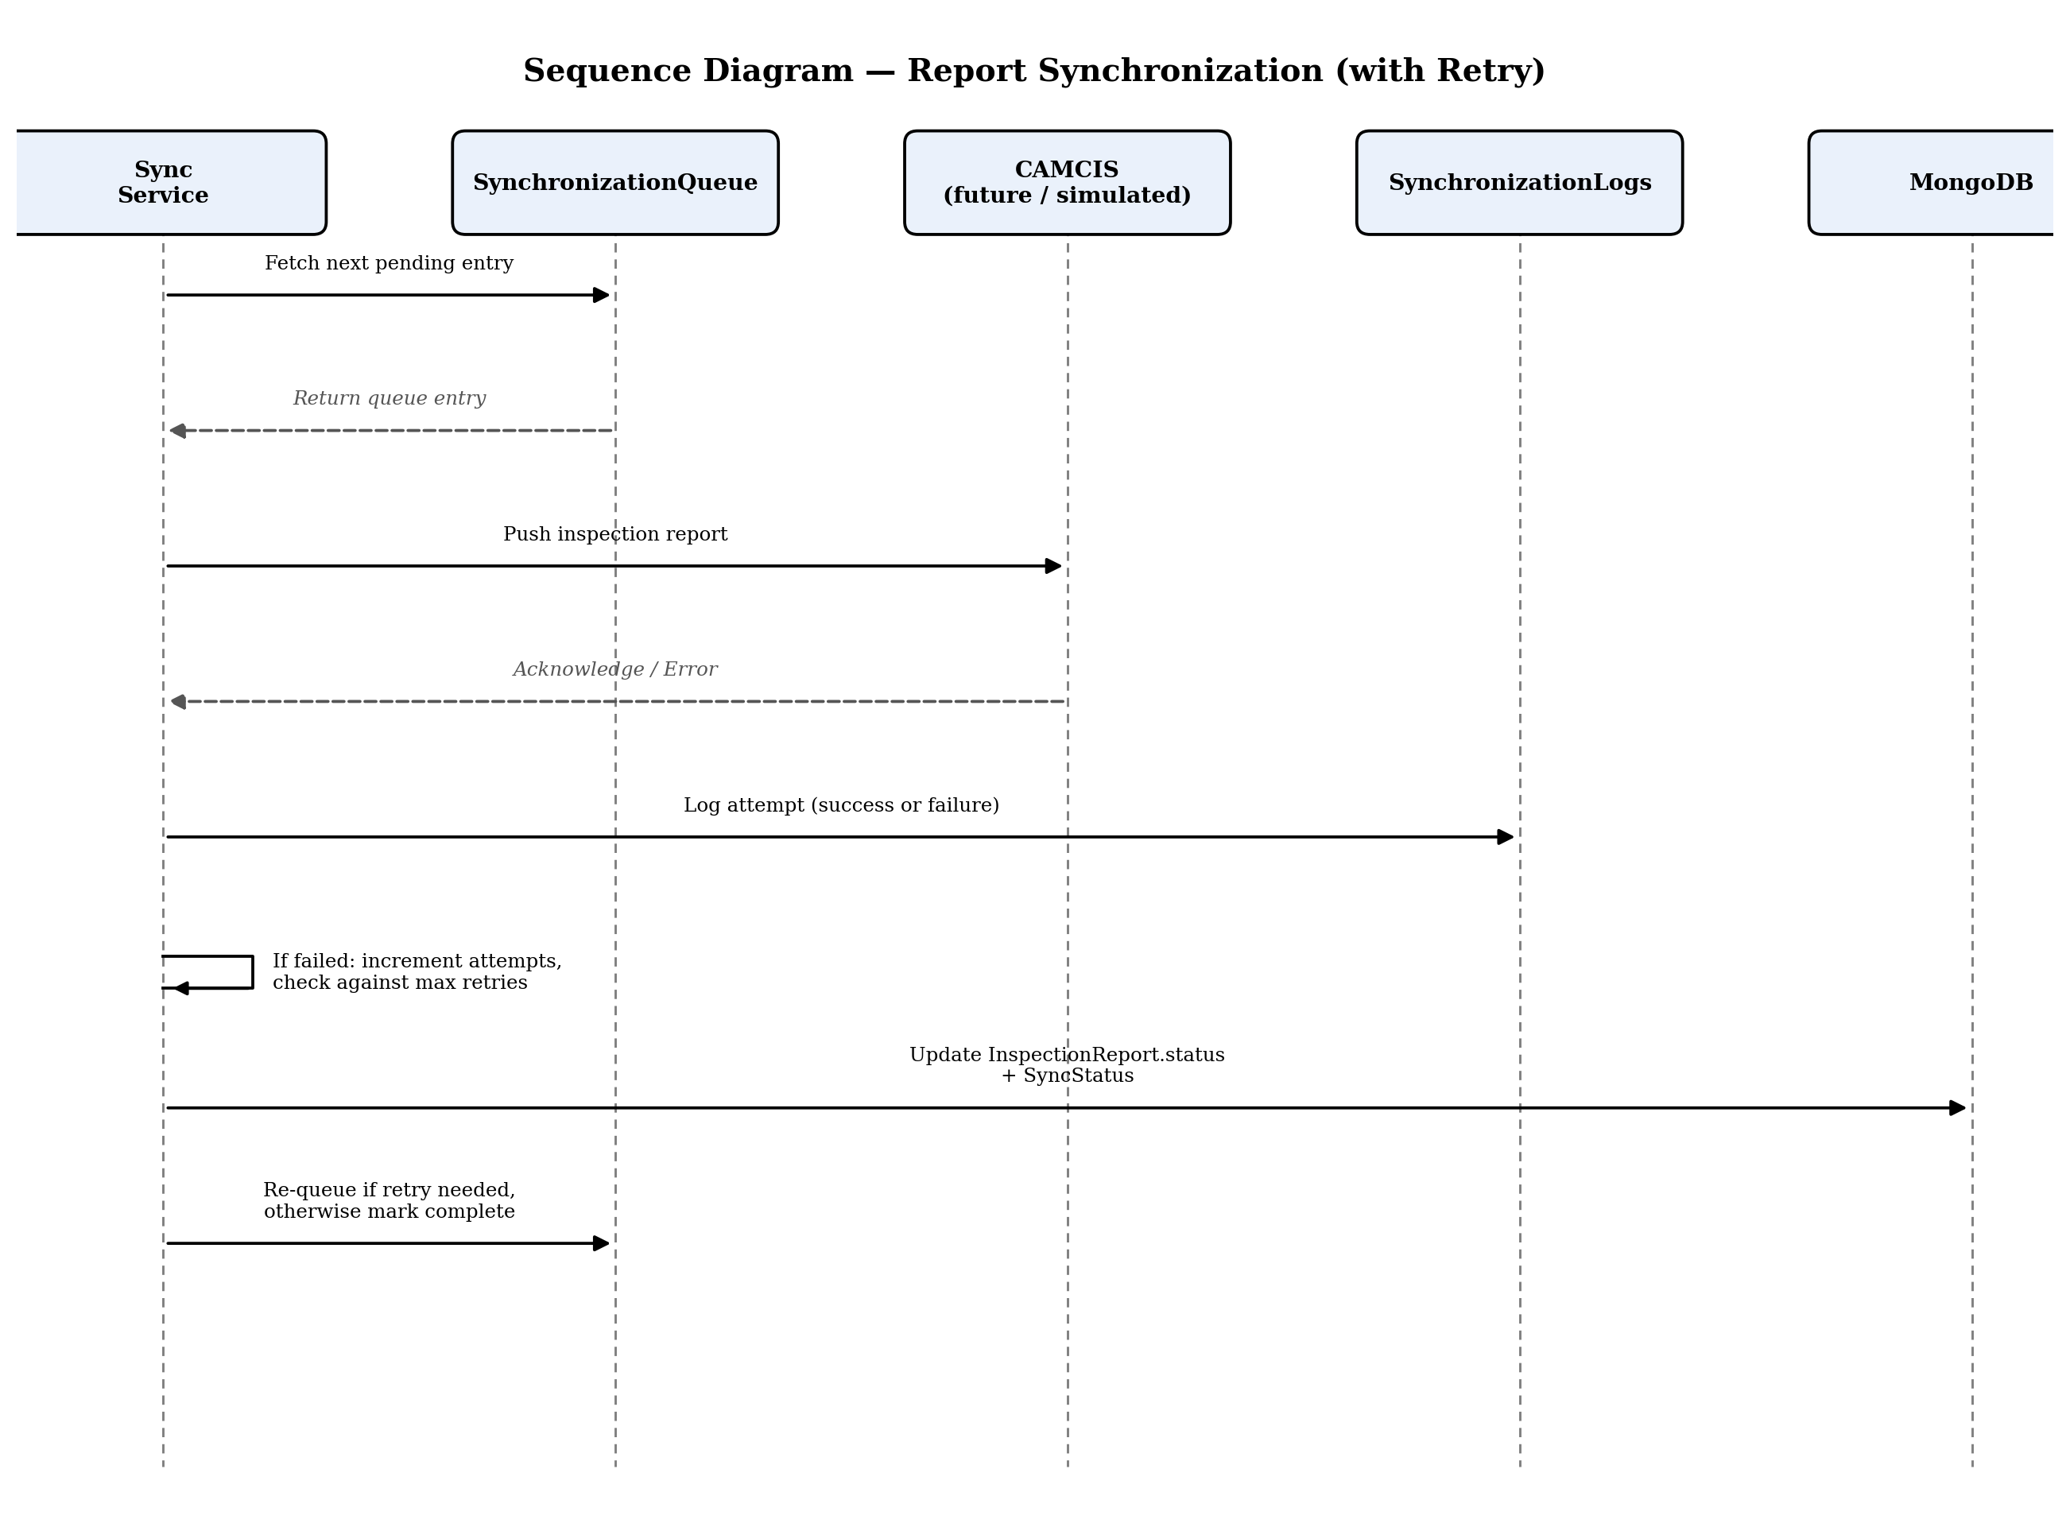
Figure 10: Sequence diagram — report synchronization with retry.
10. Activity Diagram
The activity diagram below uses swimlanes to show responsibility across the officer, the mobile app, the backend, and CAMCIS (future integration), for the end-to-end inspection process.
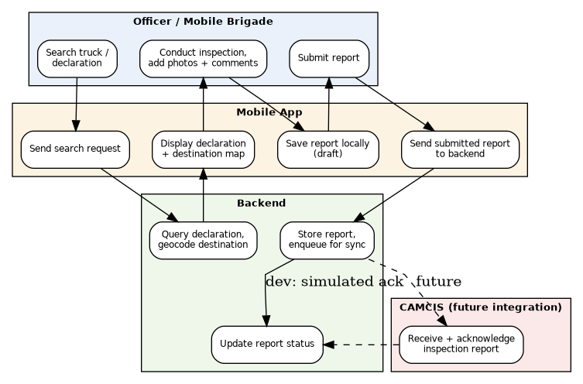
Figure 11: Activity diagram — inspection process by responsibility (swimlane).
11. Use Case Diagram
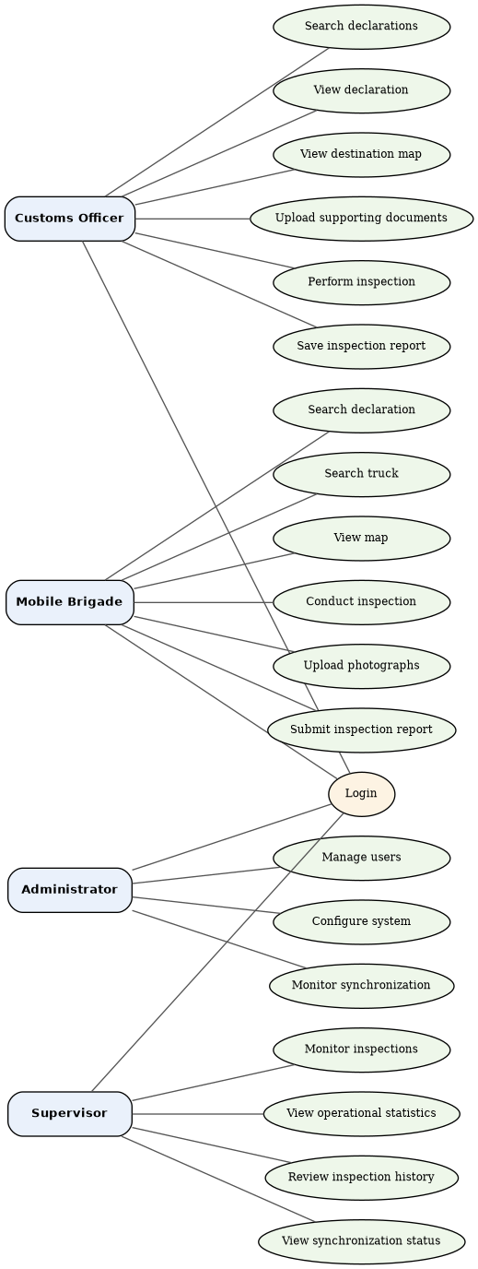
Figure 12: Use case diagram, matching SRS Section 15 exactly.
Login is shared across all four actors. Note that both Customs Officer and Mobile Brigade now have inspection-related use cases (Perform Inspection / Conduct Inspection), reflecting the approved SRS's assignment of inspection responsibilities to both roles rather than Mobile Brigade alone.
12. Component Diagram
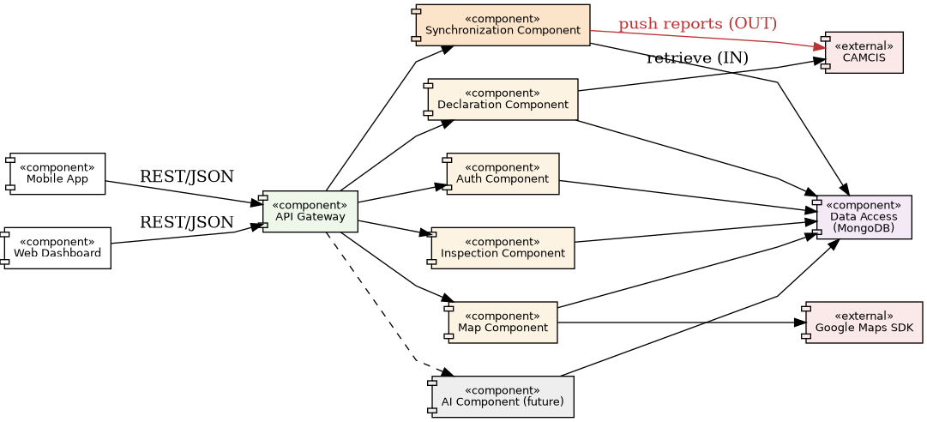
Figure 13: Component diagram showing provided/required interfaces between system components.
The Synchronization Component is the only component with an outbound interface to CAMCIS; every other component that touches CAMCIS (Declaration Component) does so read-only. This separation is deliberate: it means the single most sensitive integration point in the system, writing data toward a government platform, is isolated in one auditable component rather than scattered across the codebase.
13. Deployment Diagram
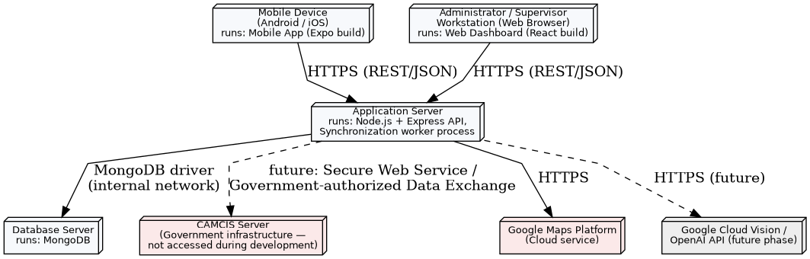
Figure 14: Deployment diagram showing physical/logical nodes.
During development, the CAMCIS Server node is not connected to; the Application Server instead reads from locally simulated data (Section 6.2, Declarations.source = 'simulated'). The dashed connection to CAMCIS represents the future production link, to be established only once authorized by Cameroon Customs.
14. Authentication Flow
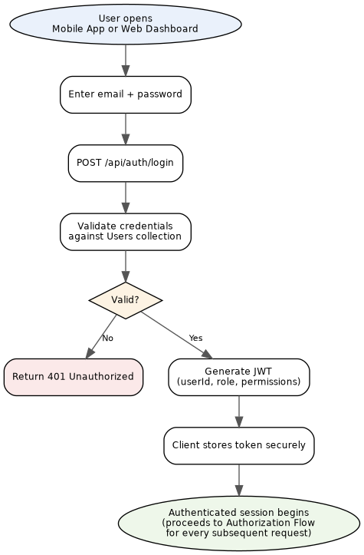
Figure 15: Authentication flow (shared by Mobile App and Web Dashboard).
Authentication is identical regardless of which client application or role is logging in. Once authenticated, every subsequent request proceeds through the separate Authorization Flow described next.
15. Authorization Flow
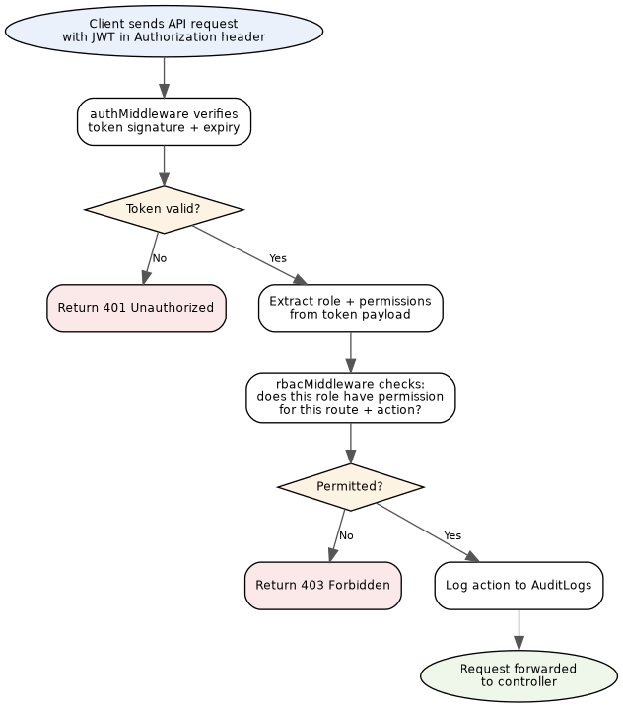
Figure 16: Authorization (RBAC) flow, applied to every authenticated request.
Authorization is deliberately separated from authentication: authentication only confirms who the user is, while authorization, re-evaluated on every single request, confirms what that user's role is permitted to do. Every permitted action is written to AuditLogs.
16. Synchronization Flow
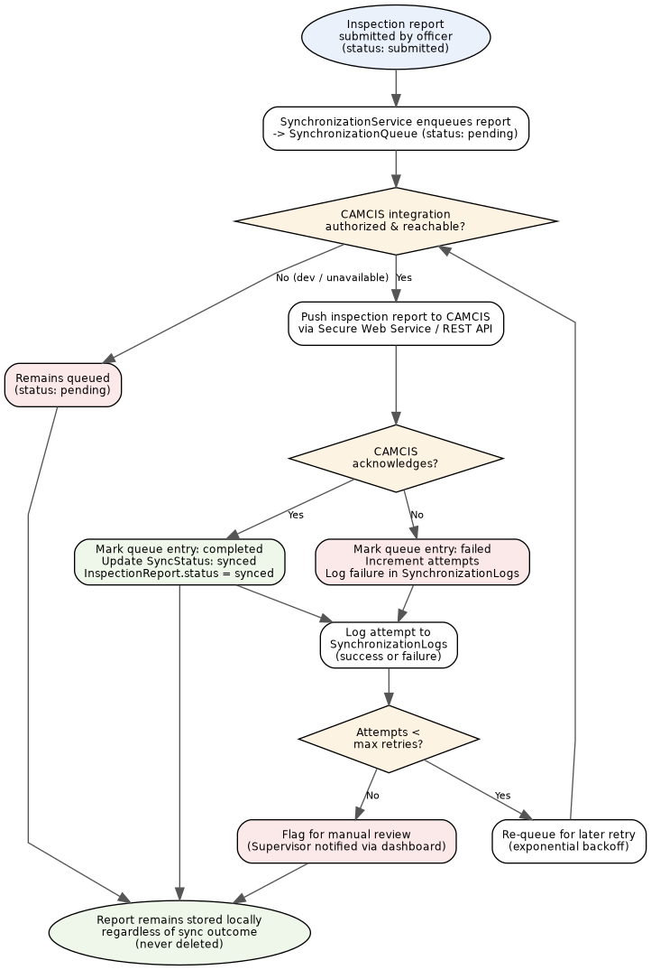
Figure 17: Synchronization flow, including retry logic and manual-review escalation.
This flow implements SRS Section 4 (Synchronization Module) and Business Rules 5–7: every inspection report is stored locally before synchronization is attempted; failed synchronizations are retried automatically up to a maximum attempt count before being escalated for manual Supervisor review; and at no point is a report deleted, regardless of synchronization outcome.
17. Google Maps Workflow
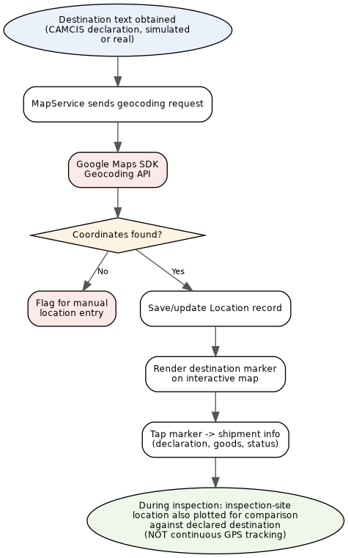
Figure 18: Google Maps destination visualisation workflow.
Per SRS Section 11, Google Maps displays the declared destination and, separately, the inspection site, to assist route planning; it explicitly does not perform real-time GPS tracking of vehicles.
18. AI Workflow (Future Phase)
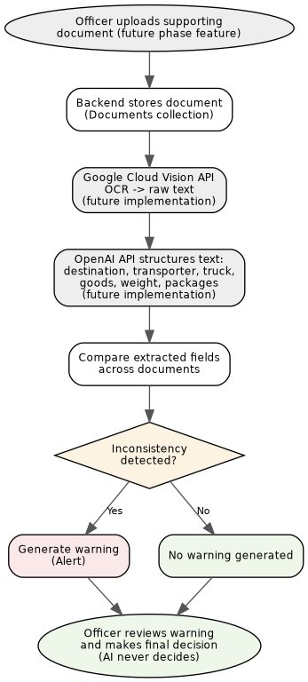
Figure 19: AI document analysis workflow — architecture defined now, implementation deferred.
SRS Section 4 states the AI Module as a firm functional requirement, while Section 13 marks the underlying OpenAI and Google Cloud Vision integrations as future-phase / post-MVP enhancements. This design resolves that by defining the AI Module's architecture and data flow now, so no redesign is needed later, while treating its implementation as deferred. In the interim, Documents are stored with aiStatus = 'not_processed' and no automated comparison or warning is generated; document review remains fully manual until this phase is implemented.
19. Inspection Workflow
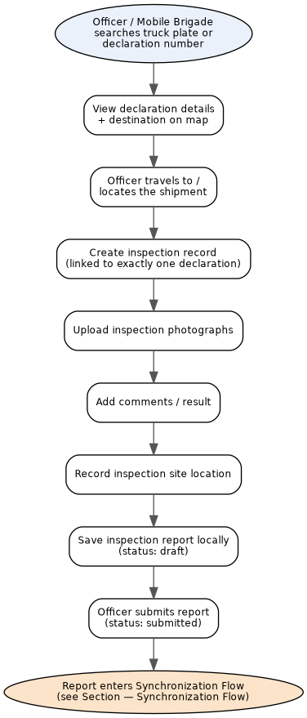
Figure 20: End-to-end inspection workflow, from search to synchronization handoff.
This is the mobile app's primary operational workflow and the reason the application exists: it takes an officer from locating a shipment, through inspecting it, to a synchronized (or safely queued) report, without requiring any manual cross-referencing of paper documents.
20. Report Synchronization Workflow
Where Section 16 (Synchronization Flow) shows the technical retry mechanics, this diagram shows the same process as a report's lifecycle of states, the view most relevant to a Supervisor monitoring synchronization status on the web dashboard.
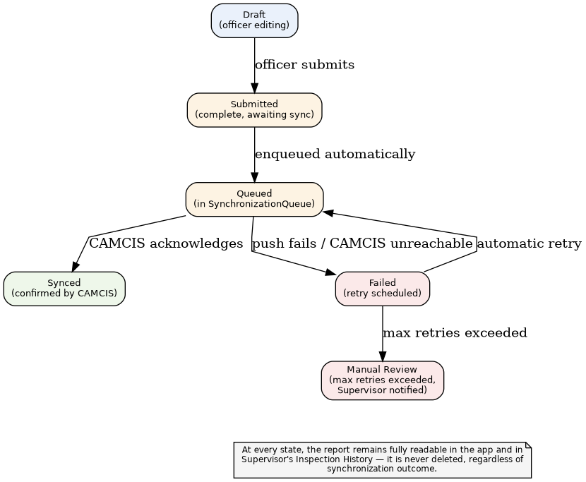
Figure 21: Report synchronization workflow, expressed as report lifecycle states.
21. API Architecture
A single REST API is consumed by both client applications. During development, declaration-retrieval endpoints serve simulated data (SRS Section 9); the endpoint contract is designed to remain unchanged when a real CAMCIS integration is authorized.
Method | Endpoint | Purpose | Access
POST | /api/auth/login | Authenticate, issue JWT | All
POST | /api/auth/logout | End session | All
POST | /api/auth/reset-password | Reset password | All
GET/POST/PUT/DELETE | /api/users | User management | Administrator
PUT | /api/users/config | System configuration | Administrator
GET | /api/declarations/search | Search by declaration no., truck plate, importer, destination, date | Officer, Brigade
GET | /api/declarations/:id | Declaration detail | Officer, Brigade, Supervisor
GET | /api/maps/destination/:declarationId | Geocoded destination + map data | Officer, Brigade
POST | /api/inspections | Create inspection (draft) | Officer, Mobile Brigade
POST | /api/inspections/:id/photos | Attach inspection photo | Officer, Mobile Brigade
PUT | /api/inspections/:id/submit | Submit report (triggers sync enqueue) | Officer, Mobile Brigade
GET | /api/inspections/history | Inspection history | Officer, Brigade, Supervisor
GET | /api/sync/status | Synchronization status overview | Administrator, Supervisor
POST | /api/sync/retry/:queueId | Manually retry a failed sync | Administrator
GET | /api/sync/logs/:reportId | Synchronization log history | Administrator, Supervisor
GET | /api/alerts | List alerts | Officer, Supervisor
GET | /api/dashboard | Aggregated dashboard data (computed live) | All (role-scoped)
POST | /api/ai/analyze/:documentId | Trigger AI extraction (future phase) | Officer (internal, disabled in MVP)
22. Security Architecture
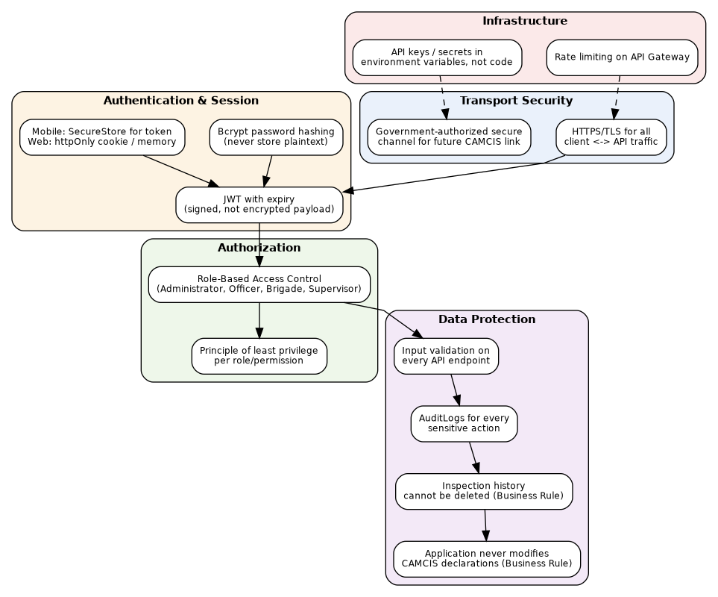
Figure 22: Security architecture, layered from transport through infrastructure.
Security is treated as a cross-cutting concern rather than a single feature: it appears at the transport level (HTTPS/TLS), the authentication level (hashed passwords, expiring JWTs, secure token storage), the authorization level (RBAC with least-privilege), the data level (input validation, immutable audit logging, undeletable inspection history), and the infrastructure level (rate limiting, secrets kept out of source code). The two business rules most specific to this project, that CAMCIS declarations are never modified and that inspection history can never be deleted, are treated as security invariants, not merely functional preferences.

